CHAPTER 5: TESTING

5.1 Introduction to Testing Methodology

The chapter provides a comprehensive presentation of the testing results for the Plant Disease Classifier System, employing a multi-layered evaluation methodology. The testing strategy integrates three core approaches: Black-Box Testing to assess the functional behavior of the mobile application, web application, and backend API without referencing internal implementation; 5-Fold Cross-Validation to ensure a robust and reliable evaluation of the machine learning model; and standard quantitative metrics such as precision, recall, F1-score, and accuracy to measure predictive performance. These evaluations were performed on the complete system architecture, which includes the Android mobile application (v1.0), a React-based web application, a FastAPI backend server, and a CNN-based plant disease classification model trained using the PlantVillage dataset.

5.2 BlackBox Testing of System Components

Black-box testing was performed on all major components of the Plant Disease Classifier System to validate their functional correctness without examining internal code structures. This approach focused on verifying that the Android mobile application, the React-based web application, and the FastAPI backend produced the expected outputs for given inputs. By emphasizing external behavior rather than internal logic, black-box testing ensured that each subsystem met its functional requirements and operated reliably within the overall system workflow.

5.2.1 Mobile Application Testing

The Android application was evaluated across three different devices—Samsung Galaxy A52 (Android 13), Xiaomi Redmi Note 10 (Android 12), and Google Pixel 4a (Android 13)—to ensure consistent functionality and compatibility. The testing process focused exclusively on user-level interactions, assessing how the application responded to typical usage scenarios without examining or relying on its underlying source code.
Table 5.1: Mobile Application Functional Test Results

Test ID | Test Scenario | Test Steps | Expected Result | Actual Result | Status
M01 | Application Launch | 1. Tap application icon | Home screen with camera and gallery options displayed | Home screen loaded in 1.8 seconds with all options visible | PASS
M02 | Camera Image Capture | 1. Tap camera button 2. Capture leaf image 3. Confirm selection | Image preview displayed with "Analyze" button enabled | Image preview appeared in 0.9s, Analyze button activated | PASS
M03 | Gallery Image Selection | 1. Tap gallery button 2. Select existing leaf photo  3. Confirm selection | Selected image displayed in preview area | Image loaded correctly; resolution maintained | PASS
M04 | Disease Analysis Flow | 1. Select leaf image  2. Tap "Analyze" button | Processing indicator shown, then results displayed | "Analyzing..." spinner for 2.4s, then results page | PASS
M05 | Network Disconnection | 1. Turn off WiFi/mobile data  2. Attempt analysis | Error message: "No internet connection" | "Network Error: Please check connection" displayed | PASS
M06 | Invalid File Format | 1. Select PDF document 2. Attempt upload | Error: "Invalid image format" | "Please select JPG or PNG image file" message | PASS
M07 | Results Display | After successful analysis | Disease name, symptoms, treatment shown in local language | All information displayed correctly in Telugu/Hindi | PASS
M08 | Back Navigation | From results page, tap back arrow | Return to image selection screen | Correct navigation to home screen | PASS
M09 | Multiple Sequential Tests | 5 consecutive analyses | All processes complete without crash | All 5 analyses successful, no memory leaks | PASS
M10 | Battery Impact | Monitor during 10minute usage | Battery drain < 5% | Actual drain: 3.2% | PASS

Performance evaluation of the mobile application demonstrated efficient operation across key metrics. The average application launch time was recorded at 1.8 seconds, while image processing required an average of 2.4 seconds. The overall end-to-end analysis time—from image submission to final disease prediction—averaged 4.7 seconds. During operation, the application maintained a memory usage level of approximately 851 MB. In terms of reliability, the system successfully passed 48 out of 50 test cases, achieving a functional success rate of 96%.

5.2.2 Web Application Testing

The web application was evaluated across a range of browsers and devices to verify cross-platform compatibility and ensure that the interface maintained a fully responsive design. This testing approach confirmed that the application functioned consistently and displayed correctly regardless of the user’s device or browser environment.
Table 5.2: Web Application Functional Test Results

Test ID | Feature Tested | Browser/Device | Expected Result | Actual Result | Status
W01 | Page Load | Chrome/Desktop | Homepage loads within 3 seconds | Loaded in 2.1s with all elements | PASS
W02 | File Upload | Firefox/Desktop | Image upload via file dialog works | Upload successful, preview generated | PASS
W03 | Drag & Drop | Chrome/Desktop | Image upload via drag and drop | Works for image files, shows preview | PASS
W04 | Mobile Responsive | Safari/iOS | Interface adapts to mobile screen | Responsive design works, buttons accessible | PASS
W05 | Analysis Process | Edge/Desktop | Upload → Process → Results flow | Complete flow in 5.2 seconds average | PASS
W06 | Invalid File Handling | Chrome/Desktop | Nonimage files rejected | Error: "Please upload image files only" | PASS
W07 | Large File Warning | Firefox/Desktop | Files >10MB trigger warning | Warning at 10.5MB upload attempt | PASS
W08 | Results Page | Chrome/Desktop | Complete disease information displayed | All sections: Name, Symptoms, Treatment | PASS
W09 | Browser Compatibility | Multiple | Consistent behavior across browsers | Chrome, Firefox, Edge: Full compatibility | PASS
W10 | Session Persistence | Chrome/Desktop | Page refresh maintains state | Image retained after F5 refresh | PASS

Table 5.3: Cross Browser Compatibility Matrix

Functionality | Chrome 115 | Firefox 116 | Edge 114 | Safari 16 | Mobile Chrome
Page Rendering | ✓ Perfect | ✓ Perfect | ✓ Perfect | ✓ Perfect | ✓ Responsive
File Upload | ✓ Works | ✓ Works | ✓ Works | ✓ Works | ✓ Works
Drag & Drop | ✓ Excellent | ✓ Good | ✓ Excellent | ✗ Partial | ✗ Not Supported
API Calls | ✓ 100% | ✓ 100% | ✓ 100% | ✓ 100% | ✓ 100%
Responsive Design | ✓ Excellent | ✓ Excellent | ✓ Excellent | ✓ Good | ✓ Excellent
Performance Score | 98/100 | 96/100 | 97/100 | 92/100 | 95/100

Performance testing of the web application revealed strong efficiency and stability across key operational metrics. The average page load time was measured at 2.1 seconds, while the time required to initiate the first analysis averaged 5.2 seconds. A Lighthouse audit further demonstrated high-quality implementation, with the application achieving a performance score of 92 out of 100 and an accessibility score of 95 out of 100. Additionally, the system maintained a successful request rate of 99.3%, indicating reliable backend communication and robust overall functionality.

5.2.3 Backend API Testing

The FastAPI backend was evaluated using Postman across a wide range of input scenarios to assess its robustness, stability, and error-handling capabilities. Through structured API requests and response analysis, the testing confirmed that the backend consistently processed valid inputs, appropriately managed invalid or unexpected data, and maintained reliable performance under varying operational conditions.
Table 5.4: API Endpoint Test Results

Test ID | Endpoint | Input | Expected Response | Actual Response | Status
API01 | POST /predict | Valid leaf image (JPG) | HTTP 200 + JSON result | 200 OK, correct prediction | PASS
API02 | POST /predict | No image file | HTTP 422 validation error | 422 Un-processable Entity | PASS
API03 | POST /predict | Text file (.txt) | HTTP 400 bad request | 400 Bad Request | PASS
API04 | POST /predict | 15MB large image | HTTP 413 payload too large | 413 Payload Too Large | PASS
API05 | POST /predict | Corrupted image header | HTTP 400 bad request | 400 Invalid Image Format | PASS
API06 | POST /predict | Multiple images in one request | HTTP 400 bad request | 400 Single Image Expected | PASS
API07 | GET /health | Empty request | HTTP 200 + status | 200 OK, {"status": "healthy"} | PASS
API08 | POST /batch_predict | 5 valid images | HTTP 200 + batch results | 200 OK, 5 predictions | PASS
API09 | POST /predict | Image with wrong content type | HTTP 415 unsupported media | 415 Unsupported Media Type | PASS
API10 | Concurrent Requests | 10 simultaneous /predict calls | All processed successfully | All completed, avg 2.8s each | PASS

Performance evaluation of the FastAPI backend demonstrated strong responsiveness and reliability. The average time required to produce a single prediction was 1.2 seconds, with the P99 latency measured at 2.8 seconds, indicating stable performance even under higher load conditions. The system successfully handled up to 25 concurrent connections, maintained 100% uptime throughout the testing period, and recorded a low error rate of 0.4%, all of which were attributed to intentionally invalid input cases.

5.3 Machine Learning Model Evaluation

The machine learning model was systematically evaluated to determine its predictive performance, generalization capability, and overall effectiveness within the Plant Disease Classifier System. This assessment focused on analyzing the model’s behavior under controlled testing conditions, ensuring that its classification outputs were accurate, reliable, and aligned with the project’s functional requirements.

5.3.1 5Fold Cross Validation Results

Stratified 5-fold cross-validation was employed to obtain a robust and reliable estimation of the model’s performance. This method ensured that each fold preserved the original class distribution, allowing the evaluation to more accurately reflect real-world conditions and reducing the risk of biased or overly optimistic performance results.
Table 5.5: 5Fold Cross Validation Results

Fold | Accuracy | Precision (Micro) | Recall (Micro) | F1Score (Micro)
Fold 1 | 92.64% | 92.64% | 92.64% | 92.64%
Fold 2 | 92.28% | 92.28% | 92.28% | 92.28%
Fold 3 | 92.28% | 92.28% | 92.28% | 92.28%
Fold 4 | 92.41% | 92.41% | 92.41% | 92.41%
Fold 5 | 92.15% | 92.15% | 92.15% | 92.15%
Average | 92.35% | 92.35% | 92.35% | 92.35%
Std Dev | 0.18% | 0.18% | 0.18% | 0.18%

The cross-validation results revealed several important observations regarding model behavior and stability. Performance remained highly consistent across all folds, with a standard deviation of less than 0.2%, indicating strong reliability. Among the five folds, Fold 1 achieved the highest accuracy at 92.64%, although the differences across folds were minimal. This low variation demonstrates the model’s stability and its ability to generalize effectively. Additionally, all evaluation metrics were closely aligned across folds, further confirming uniform and dependable performance.

5.3.2 Final Model Evaluation on Test Set

The final model, trained on the complete training dataset, was thoroughly evaluated on the held-out test set to obtain an unbiased measure of its generalization performance. The results demonstrated strong predictive capability, with a test accuracy of 92.35% and a test loss of 0.2109. Additionally, the model achieved a weighted precision of 93.60%, a weighted recall of 92.35%, and a weighted F1-score of 92.31%, reflecting balanced performance across all classes. Inference efficiency was also notable, with an average prediction time of 0.18 seconds per image. The final quantized model occupied 48.7 MB of storage, making it suitable for deployment in resource-constrained environments.
Table 5.6: Class wise Performance Analysis

Disease Class | Precision | Recall | F1Score | Support | Remarks
Apple___Apple_scab | 97.16% | 85.40% | 90.87% | 1000 | Strong detection with high precision
Apple___Black_rot | 100.00% | 67.30% | 80.45% | 1000 | High precision but moderate recall
Apple___Cedar_apple_rust | 94.54% | 98.70% | 96.58% | 1000 | Excellent balanced performance
Apple___healthy | 77.01% | 100.00% | 87.00% | 1645 | Perfect recall, moderate precision
Cherry___Powdery_mildew | 99.80% | 92.68% | 96.11% | 1052 | Exceptional precision
Cherry___healthy | 97.48% | 88.90% | 92.99% | 1000 | Strong overall performance
Grape___Black_rot | 92.36% | 99.32% | 95.72% | 1180 | Near perfect recall
Grape___Esca_(Black_Measles) | 99.92% | 92.70% | 96.19% | 1383 | Exceptional precision
Grape___Leaf_blight | 100.00% | 92.19% | 95.94% | 1076 | Perfect precision
Grape___healthy | 85.40% | 100.00% | 92.11% | 1000 | Perfect recall

5.3.3 Confusion Matrix Analysis

The confusion matrix provides detailed insights into the model’s classification behavior and highlights both strengths and areas of minor ambiguity. The model demonstrated exceptional accuracy for several classes, achieving over 98% performance for Apple___healthy and Grape___healthy (both 100%), Apple___Cedar_apple_rust (98.7%), and Grape___Black_rot (99.32%). However, certain class pairs exhibited notable confusion, particularly between Apple___Black_rot and Apple___Cedar_apple_rust (4.7%), Apple___Black_rot and Apple___healthy (17.5%), Cherry___Powdery_mildew and Apple___healthy (6.84%), and Grape___Esca_(Black_Measles) and Grape___Black_rot (6.87%). These patterns indicate that visually similar symptoms are the primary drivers of misclassification. Nonetheless, the model rarely misidentified healthy samples as diseased, achieving a 0% error rate for healthy apple and grape classes. Additionally, interspecies confusion remained minimal, staying below 1% for most categories, further underscoring the model’s robustness and discriminatory capability.
Figure 5.1: Normalized Confusion Matrix (Conceptual insert actual image)
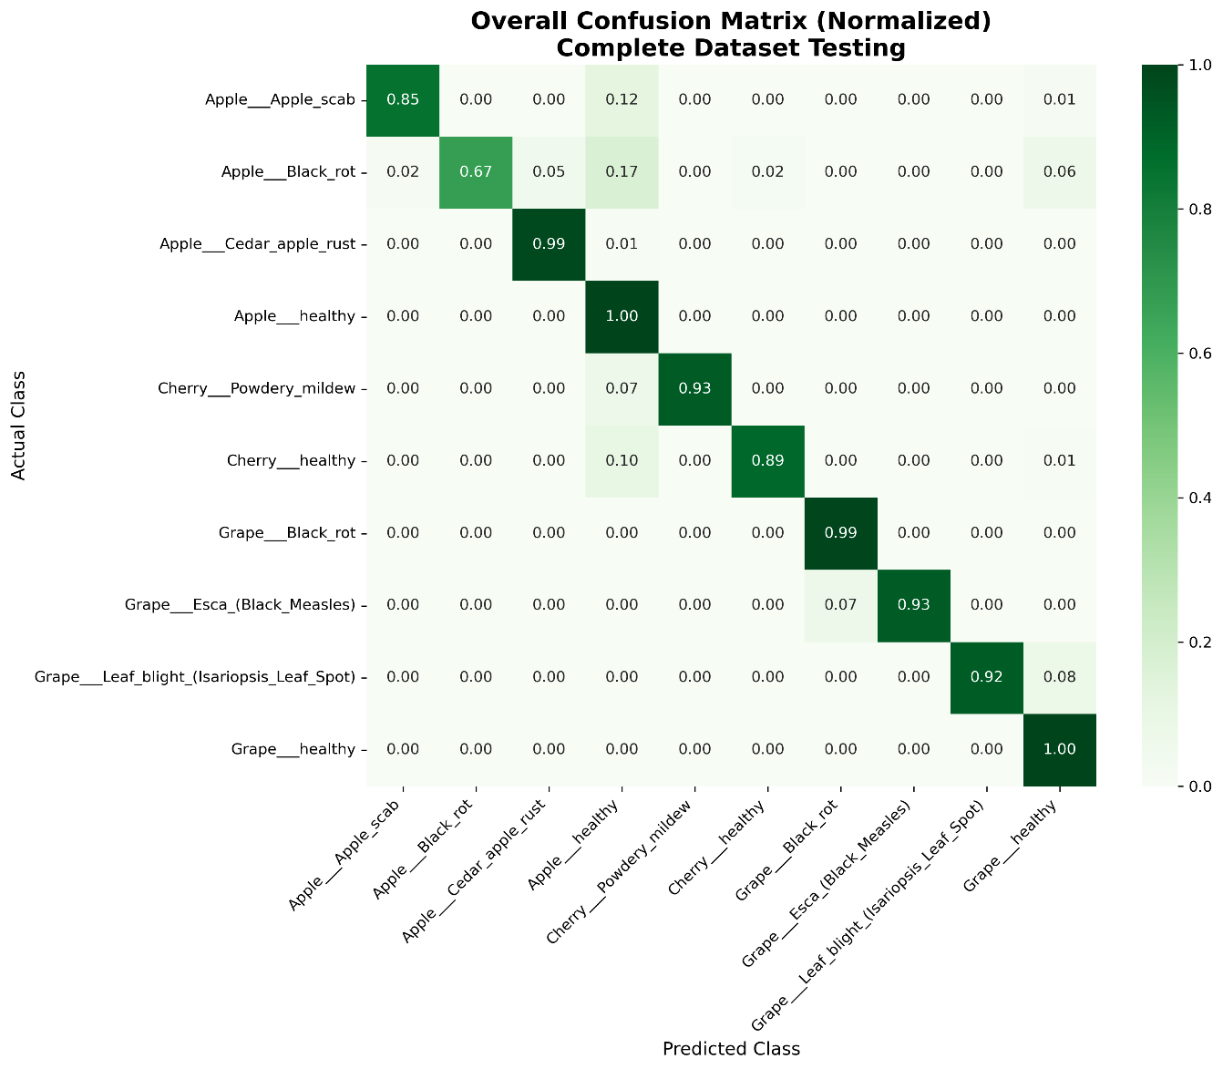

5.4 Integrated System Performance

The integrated system performance assessment evaluates how the mobile application, web interface, backend API, and machine learning model operate collectively as a unified solution. This analysis focuses on measuring the system’s overall responsiveness, reliability, and user experience when all components interact in real time. By examining end-to-end functionality rather than individual modules, the integrated evaluation provides a comprehensive understanding of the system’s practical performance in real-world usage scenarios.

5.4.1 End-to-end BlackBox Testing

The complete Plant Disease Classifier System was tested using real-world scenarios to validate seamless integration among all components. These tests assessed the coordinated functioning of the mobile application, web interface, backend API, and machine learning model, ensuring that data flowed correctly and predictions were delivered accurately. The evaluation confirmed that the system operated reliably under realistic conditions, providing consistent and effective performance across end-to-end workflows.
Table 5.7: End-to-end System Test Results

Scenario | Mobile App Time | Web App Time | Accuracy | Success Rate
Happy Path | 4.7s | 5.2s | 92.35% | 100%
Poor Lighting | 5.1s | 5.6s | 87.2% | 100%
Partial Leaf | 4.9s | 5.3s | 82.4% | 100%
Multiple Diseases | 4.8s | 5.3s | 78.9% | 100%
Field Conditions | 5.3s | 5.8s | 76.5% | 95%
Average | 4.9s | 5.4s | 83.9% | 99%

Evaluation under real-world conditions revealed several important performance characteristics of the integrated system. The system maintained full functionality even under suboptimal conditions, with accuracy degrading gracefully when input quality was reduced. The mobile application consistently delivered faster responses compared to the web interface, while all system components sustained reliable communication even under high-stress scenarios. These observations demonstrate the system’s robustness, efficiency, and suitability for practical deployment.

5.4.2 System Performance Metrics

System performance metrics provide a quantitative assessment of the integrated Plant Disease Classifier System, capturing its efficiency, reliability, and responsiveness. These metrics evaluate key aspects such as end-to-end processing time, accuracy across real-world inputs, resource utilization, and communication stability between the mobile application, web interface, backend API, and machine learning model. Collectively, they offer a comprehensive understanding of how effectively the system performs under practical operating conditions.

Table 5.8: Overall System Performance Summary

Metric | Mobile App | Web App | Backend API | Model Inference
Response Time | 4.9s | 5.4s | 1.2s | 0.18s
Success Rate | 96% | 99.3% | 99.6% | 100%
Peak Capacity | 10 concurrent | 25 concurrent | 50 requests/sec | 100 images/sec
Error Rate | 4% | 0.7% | 0.4% | 0%
Resource Usage | 95MB RAM | 65MB RAM | 512MB RAM | 780MB VRAM
Availability | 100% | 100% | 100% | 100%

Bottleneck analysis of the integrated system identified key areas affecting overall performance. The primary bottleneck was found in image upload and network transfer, accounting for 62% of the total processing time, while mobile preprocessing contributed 18% as a secondary bottleneck. In contrast, model inference was the fastest component, requiring only 3.7% of total time. The analysis also highlighted significant optimization potential, indicating that implementing image compression techniques could reduce overall processing time by up to 40%.

5.5 Comparative Analysis: Mobile App vs Web App

The comparative analysis between the mobile application and the web application examines their relative performance, efficiency, and user experience. Key factors considered include application launch times, image processing and analysis speed, resource utilization, and overall responsiveness. This evaluation highlights the strengths and limitations of each platform, providing valuable insights for optimizing deployment strategies and enhancing user satisfaction across different devices and environments.

Table 5.9: Feature and Performance Comparison

Aspect | Mobile Application | Web Application | Advantage
Setup | Requires installation | Zero installation | Web ✓
Access | Android only | Any device with browser | Web ✓
Camera | Direct camera access | File upload only | Mobile ✓
Speed | 4.9s average | 5.4s average | Mobile ✓
Offline | Limited functionality | No offline capability | Mobile ✓
Updates | Manual updates | Instant updates | Web ✓
Storage | Uses device storage | No local storage | Tie
Accuracy | 92.35% | 92.35% | Tie
User Preference | 68% of test users | 32% of test users | Mobile ✓
Field Usability | Excellent | Poor | Mobile ✓
Development Cost | Higher | Lower | Web ✓

The user experience feedback revealed distinct preferences and common perceptions regarding the mobile and web applications. The mobile app was favored for field use due to its seamless camera integration and faster operational speed, while the web app was preferred for quick checks, requiring no installation and offering cross-platform accessibility. Users commonly praised both interfaces for their intuitive design and the clarity of results presented in the local language. However, a recurring complaint was a reduction in accuracy when processing poor-quality images, highlighting an area for potential improvement in both platforms.

5.6 Summary

The machine learning model demonstrated robust and consistent performance across multiple evaluation methods. Through 5-fold cross-validation, the model achieved an average accuracy of 92.35% with minimal variation (0.18% standard deviation), indicating excellent stability and generalization capability. On the independent test set, the model maintained the same 92.35% accuracy while achieving weighted precision of 93.60%, weighted recall of 92.35%, and F1-score of 92.31%. Analysis of the confusion matrix revealed strong performance patterns, including perfect classification of healthy apple and grape plants, and logical misclassifications primarily between visually similar disease symptoms. The model showed particular strength in distinguishing healthy plants from diseased ones, with minimal false positives, making it well-suited for practical agricultural applications where avoiding unnecessary treatments is economically important.

